

**Vision and Scope Document**

**for**

**Requests Tickets Management System**

**Prepared by:**

**Ibañez, Shaun Mathew T.**

**Talosig, Buena Alexey Y.**

**Vertudes, Zian Denisse G.**

**Bariuan, Krisper Jane H.**

**MI151**

**October 7, 2017**

***Vision and Scope for Requests Tickets Management System***

***Page ii***

**Table of Contents**

|  |  |  |  |
| --- | --- | --- | --- |
| Table of Contents ................................................................................................................ | | | ii |
| Revision History ................................................................................................................. | | | ii |
| 1. | Business Requirements ................................................................................................. | | 1 |
|  | 1.1. | Background ............................................................................................................ | 1 |
|  | 1.2. | Business Opportunity ............................................................................................ | 1 |
|  | 1.3. | Business Objectives and Success Criteria ............................................................. | 1 |
|  | 1.4. | Customer or Market Needs .................................................................................... | 1 |
|  | 1.5. | Business Risks ....................................................................................................... | 1 |
| 2. Vision of the Solution ................................................................................................... | | | 2 |
|  | 2.1. | Vision Statement.................................................................................................... | 2 |
|  | 2.2. | Major Features ....................................................................................................... | 2 |
|  | 2.3. | Assumptions and Dependencies ............................................................................ | 2 |
| 3. | Scope and Limitations................................................................................................... | | 2 |
|  | 3.1. | Scope of Initial Release ......................................................................................... | 2 |
|  | 3.2. | Scope of Subsequent Releases ............................................................................... | 2 |
|  | 3.3. | Limitations and Exclusions ................................................................................... | 3 |
| 4. | Business Context ........................................................................................................... | | 3 |
|  | 4.1. | Stakeholder Profiles ............................................................................................... | 3 |
|  | 4.2. | Project Priorities .................................................................................................... | 4 |
|  | 4.3. | Operating Environment ......................................................................................... | 4 |

**Revision History**

|  |  |  |  |
| --- | --- | --- | --- |
| **Name** | **Date** | **Reason For Changes** | **Version** |
|  |  |  |  |
|  |  |  |  |
|  |  |  |  |
|  |  |  |  |

***Vision and Scope for Requests Tickets Management System*** ***Page 1***

**1. Business Requirements**

SM Hotels and Convention’s goal is to satisfy the guests by providing better quality of service. The requests tickets management system will serve as a stepping stone for the corporation to achieve excellent services for the guests. In addition, it is crucial for every company to have a good tickets management system that will allow the employees to review and analyse the guest’s requests through creating tickets that will display all the details regarding the requests. By having the ability to review and analyse the requests, better and fast response will be given to the guests for their satisfaction. Also, an automatic escalation of tickets will be a huge help for the corporation. The automatic escalation will serve as an efficient move for the corporation to respond to the requests of the guests right away.

**1.1. Background**

Shoe Mart (SM) Hotels and Convention is an expanding business that faces difficulties in keeping track of the requests of the guests. The company manually calls the concerned departments to resolve a request and complaint. However, the process was claimed to be untimely by the company itself. Considering the company’s inconsistency in keeping track of the requests, the corporation itself needs a system that will possibly improve the quality of services for the guests. For the corporation to have better services and sustain the guests, the tickets management system will enhance the capability of the corporation to respond to the requests in a faster and more effective way. With that, the services given by the corporation will continuously improve due to the fact that having the ability to respond to the requests of the guests in a better way results to better service performance.

**1.2. Business Opportunity**

Service quality and customer satisfaction have always been the top priority in every hotels nationwide. The Requests Tickets Management System will provide the SM Hotels and Convention an efficient process of resolving requests of the guests which can be a stepping stone for the company to achieve excellent services for the guests. By using the system, the company will be able to respond to the requests of the guests in a fast and effective way. With that, the services given by the corporation will continuously improve due to the fact that having the ability to respond to the requests of the guests in a better way results to better service performance.

**1.3. Business Objectives and Success Criteria**

The project aims to provide a tickets management system that will automatically monitor all the requests from the guests for the corporation that will be convenient to the employees of the corporation itself. The employees will easily monitor all the requests which will allow faster response resulting to having better quality of services. Another goal for the system is to clearly display the status of each request for the employees to see all the requests that need to be resolved and if not yet resolved and the ticket created exceeded

***Vision and Scope for Requests Tickets Management System*** ***Page 2***

the allotted time, the ticket will be sent to the department head automatically. In order for the system to achieve its goals, the following must be done.

Specific Objectives:

* Creation of a ticketing module that will allow the creation of tickets and will notify the employees regarding the ticket and its details immediately after its creation
* Creation of a business analysis module that will allow the corporation to review the tickets created
* Creation of an automated escalation process of tickets management system of SM Hotels and Conventions

**1.4. Customer or Market Needs**

Requests Tickets Management System (RTMS) aims to provide the users a concise and reliable process of creating tickets for the handling of requests of the guests. Tickets are created to compile all the requests of the guests. The nature of the ticket itself, category, department involve and the time of the whole process is included in the ticket.

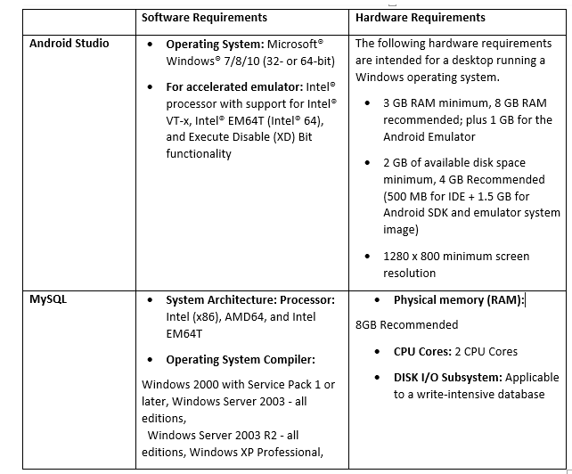

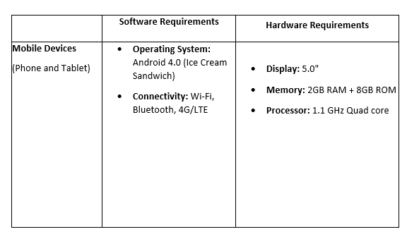

**1.5. Business Risks**

The Request Tickets Management System will allow all employees to have smart phones for the employees to be notified whenever there is a task given. However, with the employees carrying around smart phones during work might be a huge disadvantage for the company. The employees might be distracted because of the smart phones which might lessen the quality of the services of the company.

***Vision and Scope for Requests Tickets Management System*** ***Page 3***

**2. Vision of the Solution**

The Request Management System will provide the authorities and all the employees an application where all are capable of logging in. However, the system will not allow the regular employees create their own accounts for the security of the company. Through creating tickets (done by the front desk employee), the department heads can distribute task to the employees in a faster way.

**2.1. Vision Statement**

The Request Ticket Management System will serve as guide to the SM Hotels and Convention in keeping track of all the requests of the guests. The system will allow the front desk to create a ticket as soon as a guest calls to request and to send the ticket to the departments responsible. In addition, the system will provide the company a database that will contain all the tickets.

**2.2. Major Features**

1. The system has a ticketing module that focuses on the monitoring of the tickets. The tickets created will contain the nature of the ticket itself, category, department involve and the time of the whole process. The module also includes the sending of tickets and the notifications about the tickets sent.

2. Statistics such as the tallying of the tickets based on their nature, ticket generation, responsible departments and average time of the whole process is included in the Business Analysis Module of the system.

3. The regular employees are allowed to ask for help in resolving a request by sending a message to the higher authority.

4. If the request exceeded the allotted time and remains unsolved, the ticket will be sent to the higher authority automatically.

**2.3. Assumptions and Dependencies**

The department heads doesn’t need to assign an employee for the ticket created by the front desk. The system will automatically send the generated ticket to the employees working on a particular shift.

***Vision and Scope for Requests Tickets Management System*** ***Page 4***

**3. Scope and Limitations**

**3.1. Scope of Initial Release**

The requests tickets management system will implement a ticketing module which includes the creation of tickets, the sending of tickets and the notifications about the tickets sent. The tickets created will contain the nature of the ticket itself, category, department involve and the time of the whole process. In addition, the tickets will be monitored. The ticket monitoring module will display the tickets with pending status and if the request remains unsolved, the complaint will be sent to the department head. Also, statistics about the requests will be provided by the business analysis module such as the tallying of the tickets based on nature, concerned departments, ticket generation and average time before the requests will be resolved.

In addition, all employees are allowed to have a smart phone which will allow the system to notify all the employees. Also, all employees that are assigned to respond to the tickets have the ability to seek help from the higher authority by sending a message regarding the reason why the employee needed help.

**3.2. Scope of Subsequent Releases**

An added feature can be considered in the future to the system. The system can locate where the employees are on the hotel. Even though the tickets can be sent to all the available employees when a ticket is generated, it is somehow more convenient if the employee is just around the area of the guest’s room.

**3.3. Limitations and Exclusions**

The higher authorities are the only ones that are allowed to create accounts for the regular employees for privacy assurance. Also, only the guest service representative is capable of creating tickets that are to be sent to the departments responsible.

***Vision and Scope for Requests Tickets Management System*** ***Page 5***

**4. Business Context**

**4.1. Stakeholder Profiles**

|  |  |  |  |  |
| --- | --- | --- | --- | --- |
|  | **Major** |  |  |  |
| **Stakeholder** | **Value** | **Attitudes** | **Major Interests** | **Constraints** |
|  |  |  |  |  |
| Executives | Improve employee performance;  Improve customer satisfaction; | Commitment to improve customer service;  Hoping to acquire more customers through good reviews from previous customers; | Management of requests of customers;  Automated process of handling requests | Budget not applicable  Company policy about mobile phones |
|  |
|  |
|  |  |
|  |  |  |  |  |
| Managers/ Department Supervisors | Increase employee performance; increase department staff (employee) productivity; | Happy with the automation of handling requests | Management of requests of customers;  Automated process of handling requests. | Company policy about mobile phones |
|  |
|  |  |
|  |  |  |  |  |
| Regular Employees | Quick execution of tasks;  Fair assessment from managers based on their performance; | Happy with the automation of handling requests | Automated process of handling requests  Escalation to a manager of a request and complaint to provide proper service to customer | Might not accept task; Might not be familiar to technology |
|  |
|  |
|  |
|  |  |  |

***Vision and Scope for Requests Tickets Management System*** ***Page 6***

**4.2. Project Priorities**

|  |  |  |  |
| --- | --- | --- | --- |
| **Dimension** | **Driver** | **Constraint** | **Degree of Freedom** |
|  | **(state objective)** | **(state limits)** | **(state allowable range)** |
|  |  |  |  |
| Schedule | Release of Version 1.0 or first iterations to be |  |  |
|  | available by 10/12 and following iterations will be in the future |  |  |
|  |  |  |  |
|  |  |  |  |
| Features |  |  | At least 60-70% of the features must be functional on the launch of the first iteration. |
|  |  |  |  |
|  |  |  |  |
|  |  |  |  |
| Quality |  |  | Must be available for use after at least 4 iterations. |
|  |  |  |
|  |  | Must pass testing to ensure availability for use after said number of iterations. |
|  |  |  |  |
| Staff |  |  |  |
|  |  | Team consists of 4 developers. |  |
|  |  |  |  |
|  |  |  |  |
| Performance |  |  | The system must not delay the process of sending and escalating a ticket by more than the time indicated in the Timing Diagram |
|  |  |  |  |
|  |  |  |  |
|  |  |  |  |

**4.3. Operating Environment**

The Request Ticket System will be used by SM Hotels during their operations. The system will be installed in mobile devices to ensure mobility of employees handling the devices to communicate with each other even if the employees are not in the same area. The Front Desk department will be handling the back-end PC where the tickets will be created which will be sent to the mobile phones of the employees that will be assigned to handle the request or complaint. These tickets will be updated per action and stored in the database and will be written in a transcript in order for an Executive or Manager to review and make a report. This report will serve as their basis for improving the service of the customer.